School No. 2
Elementary School
Parent’s Guide to PBSIS:
POSITIVE
BEHAVIOR
SUPPORT
IN
SCHOOLS

Dear Parent/Guardian(s):

Please review the information contained in this brochure with your child(ren).

*Ask your child to say the R.O.A.R.S. Motto

*Discuss the R.O.A.R.S. Motto with your child

*Ask your child to discuss examples of ways that s/he can use R.O.A.R.S. to help them learn and participate in school.

*Ask your child if s/he earned a tiger ticket at the end of each day. Talk to your child about what s/he did to earn a tiger ticket.

*Discuss ways that our behavior expectations can be used at home and in the community.

What can you do to help your child stay on the path to positive behavior?

Ask your child about his/her day at school every day.

Positively reinforce your child when s/he earns a tiger ticket.

Keep in touch with your child’s teacher to continue to build a strong home-school connection.

We look forward to working in partnership with you as we embrace PBSIS. If you have any questions please contact the school. A PBSIS team member will be glad to discuss the program in more depth with you.

School No. 2
1700 S. Wood Avenue
Linden, NJ 07036
(908) 862-3287
R.O.A.R.S. Motto

My Tiger R.O.A.R.S.

When I am:
Responsible for my behavior

Own my choices

Aim to be my best

Respect myself and others to be

Safe at School No. 2
What is Positive Behavior Support in Schools?
Positive Behavior Support in Schools is a school-wide approach based on recognizing positive contributions of students. PBSIS means students will know exactly what is expected of them. Students who take responsibility to behave positively will be recognized and rewarded in a variety of ways. A key strategy of the PBSIS framework is prevention. Through instruction and regular practice all teachers and staff members will use a consistent set of behavior expectations. Students will receive on-going instruction from teachers and staff on our school-wide expectations in all areas of the school. The classroom, recess, cafeteria, assemblies, hallways and stairwells are all settings where “Our Tiger R.O.A.R.S.”
Our Tiger R.O.A.R.S.

Responsible | Own | Aim
*Be responsible by following the teacher.  *Be responsible when you hear, “Give me 5”, voices off.  *Be responsible by walking face forward and stay to the right.  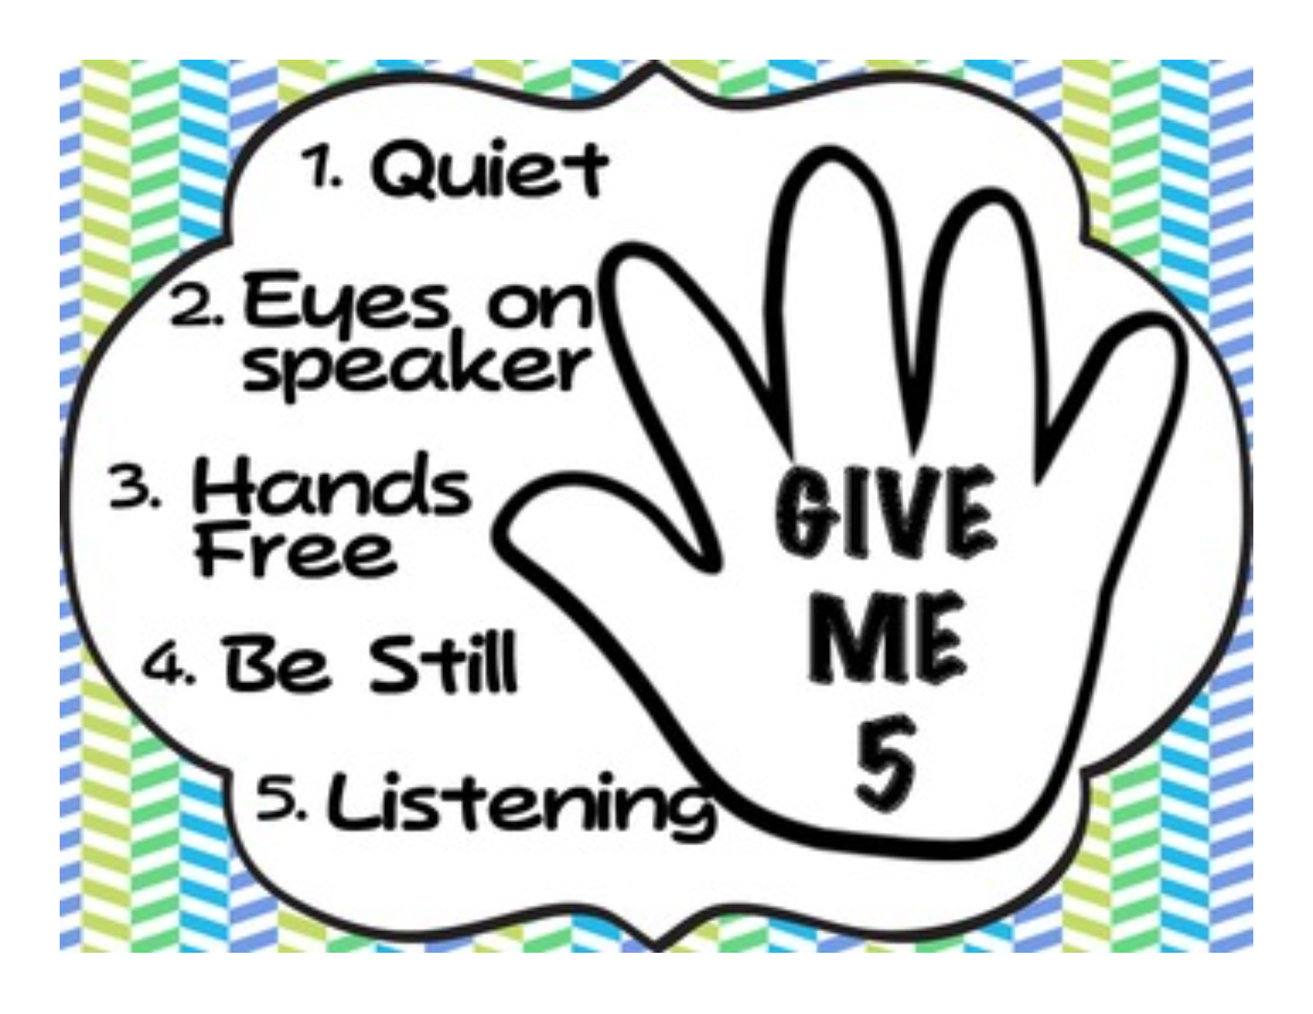 | *Own the choice to be prepared every day.  *Own the choice to walk quietly to line up.  *Own the choice to play by the rules. | *Aim to do your best work.  *Aim to speak in a soft voice.  *Aim to give a polite clap or applause.
Respect | Safety
*Show respect by keeping eyes on the speaker and listening ears.  *Show respect by listening to the adults on duty.  *Show respect by using walking feet at all times. | *Be safe by keeping hands, feet and object to yourself.  *Be safe by returning to class quickly and quietly.  *Be safe by asking permission to leave your seat.

Behavior Expectations are practiced in the classroom, recess, cafeteria, assemblies, bathroom, hallways and stairwells.

