Dear Parents, Guardians, and Students,

Welcome to the 2020-2021 school year! I know the past few months have been like no other and that we are all desiring some sense of normalcy to resume. I am eager to begin our instrumental music lessons and hope that these musical moments will bring you happiness and joy during your days and weeks ahead. Even with so much uncertainty, together we will continue to grow and become incredible musicians!

We will be working together virtually until further notice. With that said, we still have so much to learn and will do so in as similar a manner as if we were face-to-face! I will be using Seesaw, ClassDojo, and Flipgrid to share/receive information from you and your child. We will meet live for our weekly lessons using WebEx. More detailed information for using these online platforms is forthcoming.

Sadly, we will not be having a Winter Concert this year. Instead, we will be sharing our progress using our online platforms. I know it is not the same, but I believe it will help keep us all motivated to share our progress and hopefully, we will be able to perform together soon! We will stay positive!

If you are planning to rent an instrument from Elefante, I have provided the link in the Virtual Classroom page and here: https://www.shopelefantemusic.com/t-online%20rentals.aspx Click this link to be directed to the page for student rentals for the coming school year. The code for Linden Public Schools is 385552020. If your child borrowed an instrument from the school last year, it is still in your possession and will continue to be used throughout this school year. Students will not have the option to change instruments this year if they borrowed from the school for health and safety purposes.

I will be creating the lesson schedule after I have confirmed all instrumental music participants. Please be patient as I finalize this! I am hopeful to have this set up and ready to go by mid-September.

We will have a wonderful year ahead. It may bring some new challenges, but we will move through them all together! I am here for you and your children. Please feel free to reach out if you have any questions or concerns at any time.

Musically yours,

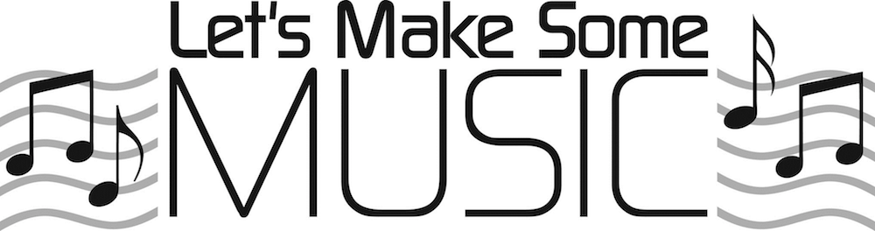
Katie Thode
Instrumental Music Teacher
School #4

