Dear School #5 Families,

Welcome to School #5! The School #5 PTA would like to take this opportunity to invite you to join the School #5 Parent Teacher Association. Each year the PTA works together with you to raise funds for educational programs to supplement the needs of our school and school families. We organize bake sales, holiday sales, book fairs and many other events. Unfortunately, we cannot accomplish any of these things without your support! It is our responsibility to give 100% support to our children. As each year passes and students move on, we strive to make the next year better. Once again, this will not be a success without your support! Please join the PTA today. We need you to be active and involved. We look forward to working with you towards a wonderful new school year. Remember...research shows that students perform best when a support system is involved!

Sincerely,

School # 5 PTA

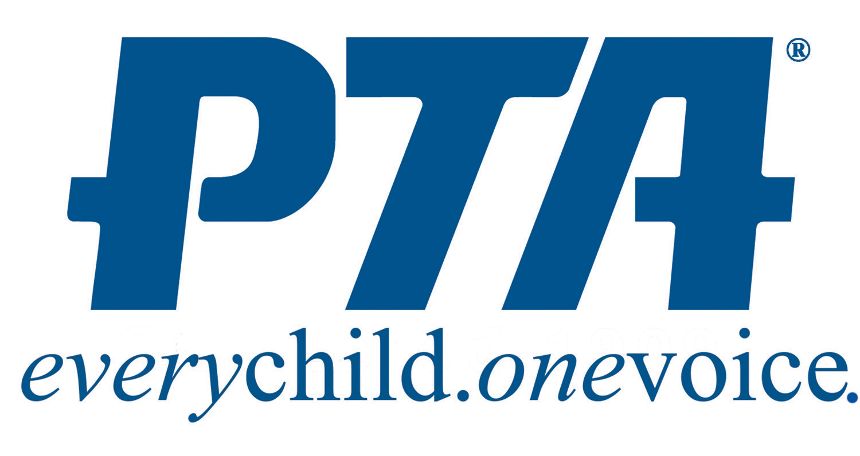

SCHOOL #5 PTA MEMBERSHIP DUES (2017-2018)

$8.00 PER PERSON*

Please Print (include all names of children attending School #5):

Parent’s Name: _______________________________________________

Student(s) Name and Teacher: __________________________________

Student(s) Name and Teacher: __________________________________

Student(s) Name and Teacher: __________________________________

Student(s) Name and Teacher: __________________________________

*If paying by check, please make check payable to: School #5 PTA

