December 2019
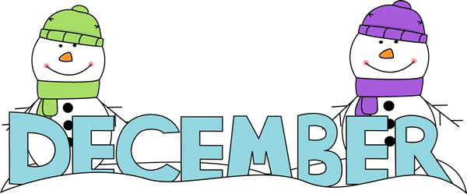
School No. 5 Laura Scamardella, Principal

“The only dreams
impossible to reach are the
ones you never pursue.”

*Student of the Month Theme for December: Citizenship*
Sunday | Monday | Tuesday | Wednesday | Thursday | Friday | Saturday
1  National Hand Washing Awareness Week | 2 | 3 | 4  Staff In-Service  Half Day with Lunch Served Dismissal Time 12:40pm | 5 | 6  1st Trimester Ends | 7  Pearl Harbor Remembrance Day
8 |  | 10  Winter Concert  7:00pm | 11 | 12  National Gingerbread House Day | 13 | 14
kl | 16 | 17 | 18 | 19 | 20  PTA Pizza Fundraiser  Half Day  No Lunch Served  Dismissal Time  12:25pm | 21
22 | 23 | 24 | 25 | 26 | 27 | 28
29 | 30 | 31

9
2nd Trimester Begins

Holiday Boutique Dec. 17, 18, 19

School Closed for Winter Recess
School Reopens: Thursday, January 2, 2020

December Parent Tip: Provide your child with homework support. Set a regular time each day for doing homework that is free of distractions. Let your child know that homework is important and valuable because it reinforces important skills. Created By: Mrs. Suggs, 3rd Grade Teacher

