November 2019
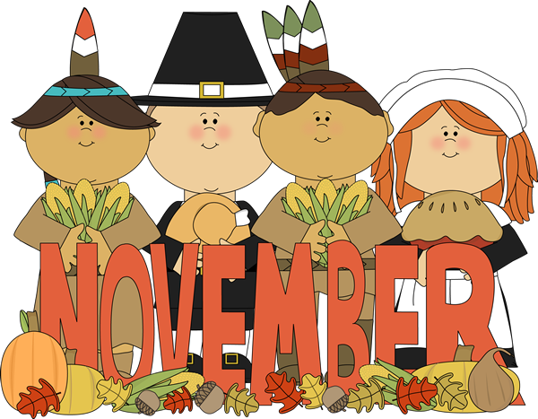
School No. 5 Laura Scamardella, Principal

“Tell me and I forget.
Teach me and I remember.

Involve me and I learn. ”
-Ben Franklin

*Student of the Month Theme for November: Manners*
Sunday | Monday | Tuesday | Wednesday | Thursday | Friday | Saturday
Fun Fact for Kids!  Three-fourths of the earth is covered with water. When astronauts first saw the planet from space, they could mostly see water. They called it “The Blue Planet.” |  |  |  |  | 1 | 2
3 |  | 5  Schools Closed for Election Day | 6 | 7 | 8 | 9
10 | 11  Veteran's Day | 12 | 13  Native America Program Grades 3-5 | 14 | 15  Fall Picture Retakes | 16
17 | 18 | 19 | 20  Vendor Fundraiser 5:30pm-8:00pm  &  PTA Meeting  6:30pm | 21 | 22 | 23
24 | 25  PBSIS Assembly  1:30pm | 26  Principal’s Luncheon 11:00am | 27  PTA Pizza Luncheon Fundraiser  Half Day No Lunch Served Dismissal Time 12:25pm | 28 | 29 |  | 30

4

Schools Closed for
NJEA Convention

American Education Week

Schools Closed for Thanksgiving Recess

November Parent TIP: November is National Family Literacy Month. The more words your child knows, the easier it is for him/her to read, write, and participate in discussions. Encourage your child to find and explore words!

Created By: Mrs. Suggs, 3rd Grade Teacher

