October 2019

School No. 5 Laura Scamardella, Principal
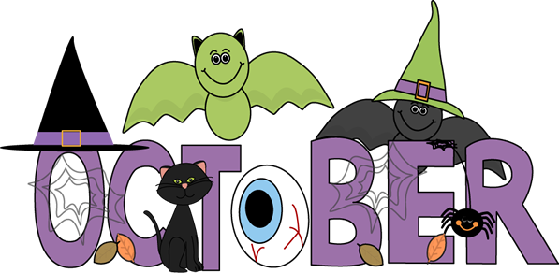
"When you
know better you do
better." -Maya Angelou

*Student of the Month Theme for October: Respect*

Book Fair 22, 23 & 24
Half Day with Lunch Served: Dismissal Time 12:40pm: Parent Teacher Conferences
National Fire Prevention Week & Week of Respect
Red Ribbon Week October 23-October 31
Sunday |  | Monday | Tuesday | Wednesday | Thursday | Friday | Saturday
 |  |  | 1  Yojo  Anti-Bullying Assembly 1:15pm Grades K-5 | 2 | 3 | 4  Hawk Rise Grade 4  AM Trip | 5
6 |  | 7 | 8  Trailside Trip  Grade 5 | 9  Schools Closed  Yom Kippur | 10  Firetruck Visit  Grades Pre-K-3 | 11  Fall Pictures | 12
13 |  | 14  Staff  In-Service  No  Students | 15 | 16 | 17  Bike Safety Assembly  9:00-9:45am  (K-2)  10:00 10:45am  (3-5) | 18 | 19
20 |  | 21 | 22 | 23 | 24 | 25 | 26
27 |  | 28  PBSIS Assembly  9:30am | 29  Principal’s Luncheon 11:00am | 30 | 31  Halloween School Parade 1:30pm  Happy Halloween! | Fun Fact for Kids!  The oldest living tree in the  world is in California and it is  around 4,843 years old.

October Parent TIP: Attendance is a critical factor in every child’s school success. Regular attendance and promptness are good habits that are expected and appreciated. Commit to excellence in attendance!
Created By: Mrs. Suggs, 3rd Grade Teacher

