Elementary School No. 6 October 22, 2018
Principally Speaking
Monday  October 22 | Tuesday  October 23 | Wednesday  October 24 | Thursday  October 25 | Friday  October 26
 | 12:40 Dismissal with Lunch Served  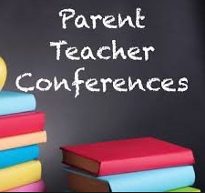 | 12:40 Dismissal with Lunch Served | 12:40 Dismissal with Lunch Served | PTA Sponsored with Dance Party  Trunk-or-Treat  5:00 - 7:00 pm

Red Ribbon Week  Parents/Guardians, this week School No. 6 will recognize and celebrate Red Ribbon week.  October 22nd Day One -Kick off Red Ribbon Week by wearing/accessorizing in red.  October 23rd Day Two -Put a cap on drugs day: wear your favorite cap.  October 24^{4t} Day Three: -Team up Against Drugs: wear your favorite team shirt.  October 25th Day Four: -Classrooms to Review Habit Five: Talk about healthy ways to deal with stress.  October 26th Day Five: -The Key to my future is being drug free. Sign and color the red ribbon pledge.  Trunk-or-Treat  Please join us on October 26th for our PTA hosted Trunk-or-Treat event. The event will run from 5 - 7 pm, at School No. 6, Each child will receive a treat bag, courtesy of the PTA. PLEASE RETURN PERMISSION SLIPS BY MONDAY, OCTOBER 22ND. WE ARE STILL LOOKING FOR CARS TO DECORATE AND CANDY DONATIONS. PLEASE SEE PERMISSION SLIP FOR MORE DETAILS. | Staff Member Highlight  Mrs. Beriont and her daughter recently had the opportunity to meet and speak to Croatian President Kolinda Grabar-Kitarovic at the NFCA International Cultural Foundation Bouquet held in New York City. She was in town to speak at the 73rd United Nations General Assembly attended by foreign dignitaries throughout the world.  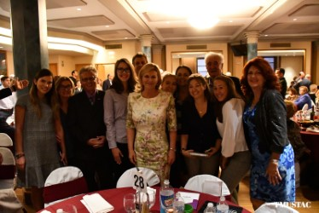  Upcoming Dates to Remember  October 22-26 - Red Ribbon Week  October 23,24,25 - Parent/Teacher Conferences  October 26th - Trunk-or-Treat  October 28th - City of Linden Halloween Parade

