DEERFIELD TERRACE SCHOOL NO. 9 - SCHOOL SPIRIT DAYS 2017-2018

This year’s School Spirit Themes will help support School No. 9 PBSIS Activities.
Please donate $1 if you choose to participate.
Friday, September 8th  School Spirit Day  Show your Tiger P.R.I.D.E. by wearing a Deerfield Terrace T-Shirt or wearing black & orange. | Tuesday, October 10th  Sports Day  Wear your favorite sports team’s shirt.  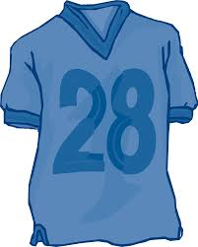 | Monday, November 13th  “World Kindness Day”  Cultural Dress- Up Day  Celebrate by wearing something that represents your culture.
Friday, December 8th  Ugly Sweater Day  It’s ugly sweater time!  Let’s see your ugliest.  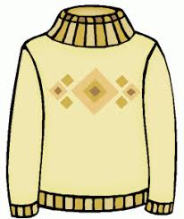 | Tuesday, January 9th  World Nerd Day  Don’t let the nerds and geeks do all the work! Dress like one and show your teacher how smart you really are! | Friday, February 9th  Crazy Hair Day  Here’s a chance to show your craziest hairstyle.  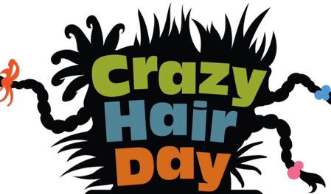
Friday, March 9th  Clone Day  Get two, three, four or more friends together and dress alike.  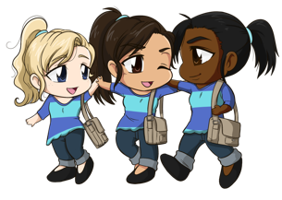 | Monday, April 9th  Hero Day  Heroes come in all shapes and sizes. From Firemen to Superman…who’s your superhero? | Wednesday, May 9th  Hat Day  Find your favorite hat and wear it all day!
Friday, June 8th
Disney Day

Dress as your favorite Disney Character or Disney Shirt.
