Deerfield School No. 9
Student Supply List – 2018-2019
Pre-Kindergarten | Kindergarten | Grade 1
Bike helmet  Sheet/Blanket or sleeping bag for cot  in a tote bag  Painting smock  Change of clothes  Tissues  Flushable wipes  Paper Towels  Please label all items with your child’s name | Backpack (Large enough to fit 9 x 12 folder)  (10) Black dry erase markers  (2) Large glue sticks  (1) Bottle of glue  (2) Boxes of tissues  (1) Container of hand sanitizer  (1) Box of markers  (1) Box of beginner crayons (8 basic colors)  (6) Beginner pencils  (1) Pair of small blunt tip scissor  (1) Composition Notebook  Change of clothes in a bag labeled  *Please label child’s name on backpack & pencil box | (1) Pencil box  (1) Dry erase markers  (1) 24 count crayons  (1) Box #2 pencils (sharpened)  (2) jumbo glue sticks  (1) pair of scissors  (2) 2-Pocket folders  (4) Marble notebooks (wide-ruled)  (1) Box of tissues  (1) Container of Clorox wipes  * Please send in all supplies labeled with your child’s name on the first day of school
Grade 2 | Grade 3 | Grade 4
Backpack that can fit in locker (no  wheels)  (2) Folders  (2) Hardcover composition book  (2) Packs of sharpened pencils with erasers  (2) Red pens or pencils  (1) Box of crayons (24 colors or more)  (4) Glue sticks  (1) Glue Bottle  (2) Boxes of tissues  (1) Pair of student scissors  (1) Pencil Box  (1) Bottle of hand sanitizer  (1) Container of antibacterial wipes | Backpack that can fit in locker (no wheels)  (3) Folders with pockets  (3) 30 ct. packs of sharpened pencils with erasers  (1) Box of crayons – 8 ct.  (1) Box of this colored pencils – 16 ct.  (1) Pack of thin markers – 8 ct.  (1) 8-Pack of glue sticks  (4) Black dry erase markers – black only  (1) Pair of student scissors  (1) Hand-held sharpener  (1) Soft pencil case – for pencil and sharpener only  (2) Boxes of tissues  (1) Old clean sock for slates  (1) Box quart size Ziploc bags  Ear buds (no headphones) in a labeled Ziploc bag  (1) Hardcover marble notebook for each of the following: Math, Reading, Writing, (4) Hard cover marble notebooks for Science & Social Studies | (1) Zipper pencil pouch (no boxes)  (5) Boxes of Tissues  (3) Large glue sticks (no liquid)  (1) Pair of earbuds or headphones in a labeled Ziplock bag  (1) 2GB Flash drive  Please note that a subject specific supply list will be included in the summer welcome letters.
Grade 5 |  | Note:
Language Arts – 1 USB Flash Drive  Pencils & Pens, 3 Composition Notebooks  Math – 1 Composition Notebook,  1 pack of Glue Sticks, Pencils  Science/Social Studies – Pencils,  1 Pack of Glue Sticks, 3 Composition  Notebooks for Science and  1 Composition Notebook for Social  Studies.  General Homeroom Supplies –  Tissue Boxes  Crayons / Colored Pencils  Highlighters  **Students in ALL classes need to be prepared and have their notebooks, pencils and pens  EVERYDAY! | 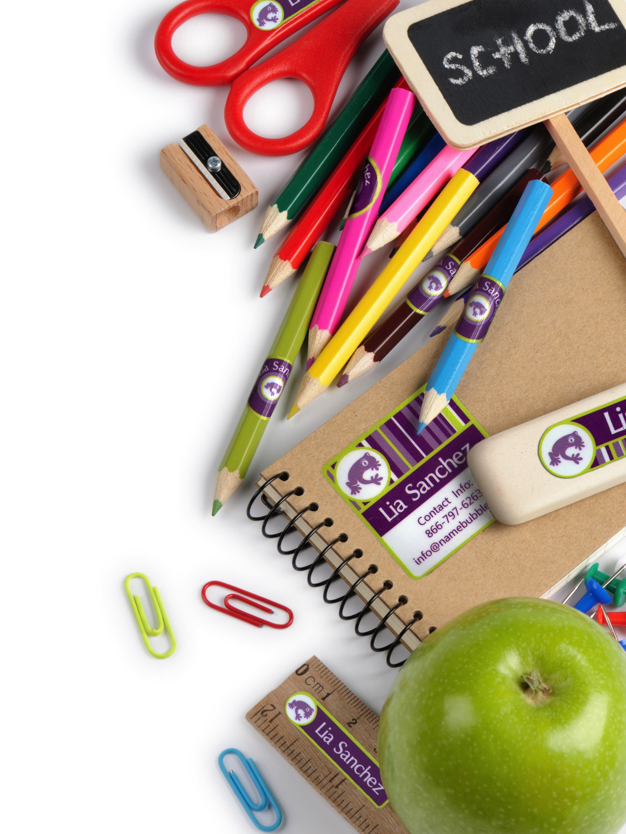 | This is a basic supply list for your child’s grade level. You may be asked to purchase a few additional supplies from your individual teacher after the first day of school.  Please try to have all supplies ready for the first day of school.

