DEERFIELD TERRACE SCHOOL NO. 9 - SCHOOL SPIRIT DAYS 2021 -2022

Thursday, September 9th  TIGER PRIDE  Show your Tiger P.R.I.D.E. by wearing a Deerfield Terrace T-Shirt or wearing black & orange. | Friday, October 8th  Sports Day  Wear your favorite sports team ! | Tuesday, November 9th  Pajama Day  Come to school dressed in your comfiest Pajamas  (please no slippers)
Thursday, December 9th  Ugly Sweater Day  It’s ugly sweater time! Let’s see your ugliest.  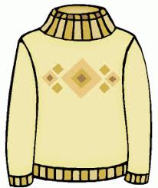 | Monday, January 10th  Teacher Day  Let’s show our teachers how much we appreciate them by dressing up just like they do.  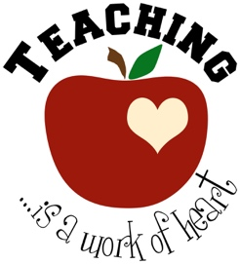 | Wednesday, February 9th  TIGER PRIDE  Show your Tiger P.R.I.D.E. by wearing a Deerfield Terrace T-Shirt or wearing black & orange.
Wednesday, March 9th  Clone Day  Get two, three, four or more friends together and dress alike.  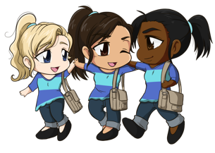 | Friday, April 8th  Celebrate Earth Day!  Dress up in beautiful bright colors to represent the colors of nature & spring. | Monday, May 9th  Pattern Day  Get Creative with your style -  extra points for multiple patterns!
Thursday, June 9th
Luau Day

