21ST CENTURY COMMUNITY LEARNING CENTER
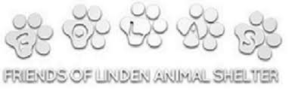
ALL DONATIONS ARE APPRECIATED AND WILL BE DELIVERED TO THE FRIENDS OF LINDEN ANIMAL SHELTER. DROP OFF YOUR ITEMS TO ROOM 213.
LIST OF ITEMS NEEDED:

CANNED DOG AND CAT FOOD
CAT TOY AND SCRATCHERS
CAT LITTER
LAUNDRY DETERGENT
DOG TREATS
TISSUES
PAPER PLATES
PAPER TOWELS
PILLOW CASES, SHEETS, TOWELS (can be used)
BLANKETS
BLEACH
YARN TO CROCHET BLANKETS
HEAVY DUTY CHAIN AND MATERIAL LEASHES
BABY WIPES
KONG DOG TOYS
PLASTIC CARRIER BAGS
DISH DETERGENT
HYDROGEN PEROXIDE
COTTON BALLS

WWW.FOLAS.ORG

