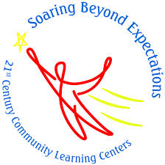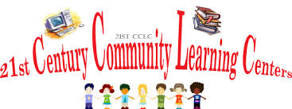

* Daily Homework Time with a Certified Teacher and Paraprofessional
* Daily Sandwich, Juice and Snack
* Rotating Enrichment
* Variety of Daily Recreation Classes
* STEM Integration
* Student and Family Class Trips
* Community Service Projects
* Individual and Small Group Counseling
* Mentoring
* Extended Library and Media Hours
* Family Nights and Workshops
* Summer STEM Academy

**2:45 -3:45 pm**

Homework and Daily Snack

**3:45-4:45 pm**

Enrichment Class (Language Arts, Mathematics, Character Education, Physical Education, Media Technology and STEM)

**4:45-5:45 pm**

Recreation Class (Open Gym, Movie Screening, Jewelry Making, Game Room, Candy Bingo, Open Media, Art, Crochet, Chess and much more…)

# **21st CENTURY**

# **DAILY SCHEDULE**

***LINDEN***

***PUBLIC SCHOOLS***

**21ST CENTURY COMMUNITY LEARNING CENTER**

## **21st CCLC ACTIVITIES AND SERVICES**

**Joseph E. Soehl**

**Middle School**

300 East Henry Street

Linden, NJ 07036

(908) 486-0550

Ext. 8786

The Linden Public School District has received the 21st Century Community Learning Center Grant Award from the New Jersey Department of Education. The grant has enabled the district to coordinate an after-school program for students in grades six through eight at Joseph E. Soehl Middle School. The program coordinates activities from 2:45-5:45 pm each day that regular school is in session. The 21st Century Community Learning Center integrates STEM activities throughout the program day during the school year and summer months.

**If you have any questions or concerns please contact us:**

**Isabella Scocozza (Vice Principal & Program Director)**

(908) 486-0550 ext. 8787

[iscocozza@lindenps.org](mailto:iscocozza@lindenps.org)

**April Knight (Program Secretary)**

(908) 486-0550 ext. 8786

[aknight@lindenps.org](mailto:aknight@lindenps.org)

# 21ST CENTURY COMMUNITY LEARNING CENTER GRANT AWARD

***Is there a cost to any of the 21st CCLC services for my child?***

No, there is no cost to the parents or guardians of Joseph E. Soehl Middle School. The after school program, class trips, snacks and family events are all free of charge.

***How do I enroll my child in the 21st CCLC Program?***

Parents or guardians can call or stop by the 21st Century Program Office for a registration application. Once completed, the application will be processed. Enrollment is on a first-come first-serve basis. If your child is registered in the 21st Century Program, you will receive an acceptance letter along with a calendar of events.

***If my child is absent on a particular day do I need to let the program office know?***

Yes, if your child will be absent from the program you need to call the program office to let the secretary know. The program secretary telephones each parent or guardian on a daily basis if a student has an unexcused absence. Multiple unexcused absences may result in the removal of the program.

## Q&A