Dear Parents/Guardians,

The 21st Century Community Learning Center will coordinate an afterschool program at Joseph E. Soehl Middle School for the 2021-2022 school year. This will be a free in-person afterschool program from 2:45-5:45 pm and will run from September 13, 2021 through June 10, 2022. The program will offer homework assistance, enrichment activities and recreational offerings on a daily basis. Some examples of our enrichment activities will be Language Arts, Mathematics, Physical Education, SEL and STEM. A variety of recreational activities will be planned for students to choose from such as painting, yoga, open gym, crafting, mural making and robotics. 21st Century will also provide parenting workshops, class trips, counseling sessions, family nights and much more.

If you are interested in enrolling your child for the 2021-2022 school year, please complete the enclosed registration form. You can choose to email, fax or mail the application. Acceptance will be on a first come-first-serve basis. If you have any questions or concerns, contact the program office.

Sincerely,

21st CCLC Program Administration

You can also contact us via Remind:
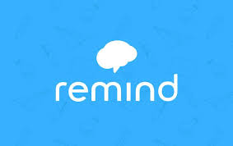
Text: #81010
Message: @21stsoehl

“This project was funded in its entirety under Title IV, Part B of the Every Student Succeeds Act (ESSA), Nita M. Lowey 21st Century Community Learning Center (21st CCLC) grant funds through a grant agreement with the New Jersey Department of Education.”

