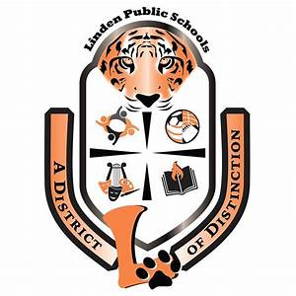

JOSEPH E. SOEHL MIDDLE SCHOOL
CLUB AND EXTRA-CURRICULAR LIST
FOR THE 2020-2021 SCHOOL YEAR

Academic Team Competition
Alliance Club
Art Club
Book Club
Chinese Culture Club
Debate Club
Diversity Club
French Club
Gardening
Girls Who Code
Honor Society
Italian Club
Math Club
Model UN
Musician’s Workshop
Peer Leadership
Spanish Club
Student Advisor Club
Volleyball
Yearbook

