- 21st CENTURY COMMUNITY
- LEARNING CENTER
- First Night Kit Program

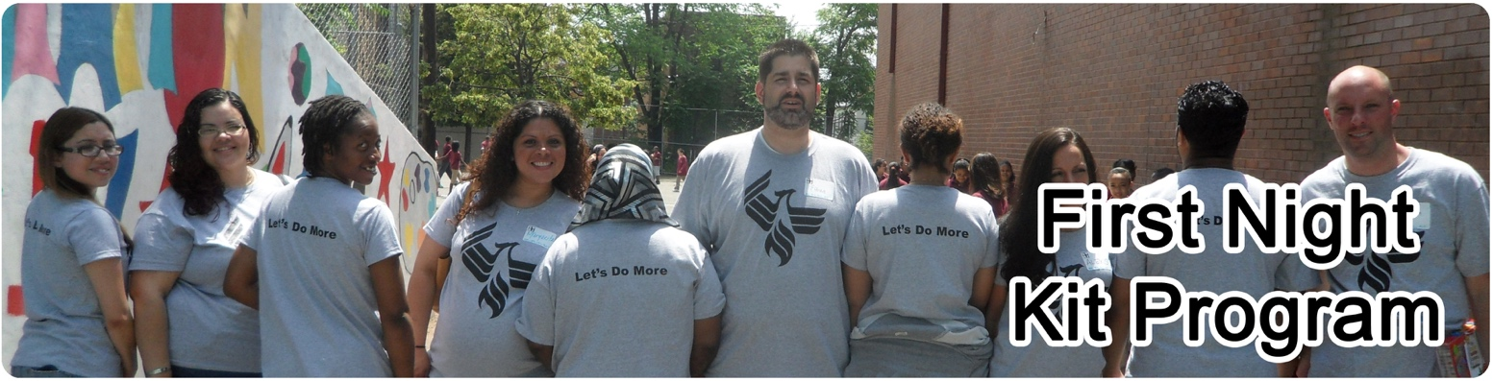

About the Program
The 21st Century Community Learning Center will collaborate with Jersey Cares to establish the First Night Kit Program. The after school program will collect donated items throughout the school year. Once we receive a certain number of items, we will coordinate a project to assemble the kits with the help of the after school program students. The First Night Kits will be distributed to local domestic violence shelters, transitional housing facilities, runaway safe havens, foster homes and other agencies with transitional populations in need of hygiene items on the “first night” of their stay.

Items to Collect
Please note that we can accept ONLY new, unopened items. A container will be located in 216A of Soehl Middle School to drop off your donations.

Items needed for First Night Kits include:

SHAMPOO
CONDITIONER
TOOTHPASTE
TOOTHBRUSH
LOTION
DEODORANT
COMB
NOTE PAD AND PEN
GALLON SIZE ZIPLOC BAGS

