21st CENTURY COMMUNITY LEARNING CENTER

RONALD MCDONALD
POP TAB DRIVE

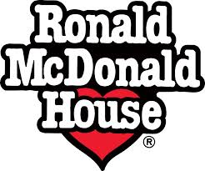
Drop off your pop tabs to support the Ronald McDonald House Children Charities.

Pop Tab Canisters are located in the Soehl Cafeteria.

